Template Name | Concept Of Operations Template
Rev/Date | Rev A 12/17/2005
Type | Optional
Associated Review List | Concept Of Operations Review List

Instructions:
General:
- The brackets < > contain explanatory information or define project-specific material to be inserted as appropriate.
- DO NOT delete any sections of this template. If sections do not apply, mark them as “N/A”.
- Delete this page and any blue guidance text upon completion of the document carefully so as not to impact other materials in the template.
- If cover and title page do not contain distribution or proprietary notations, delete the footer line “information on this page subject to the limitations cited on the title page”.
- Always start a List of Illustrations or List of Tables on a new page unless they are short enough to fit on the partial page
- This document is set up for duplex (back-to-back) printing. If the final document is 20 pages or less, use Page Setup for one-sided printing.

«ProjectName»

<ProductName>

Concept of Operations

<Date>

Contract No «ContractNo»

CDRL No. <CDRLNo>

Prepared for
«CustName»
«CustAdd»
«CustTown»


«BAEOrg»
«BAEAdd»
«BAETown»

<If applicable, cite any restrictions on distribution, classification notices, proprietary and copyright limitations>

«ProjectName»

<ProductName>

Concept of Operations

<Date>

Contract No. «ContractNo»

CDRL No. <CDRLNo>

Prepared for
«CustName»
«CustAdd»
«CustTown»

BAE SYSTEMS
«BAEOrg»
«BAEAdd»
«BAETown»

<If applicable, cite any restrictions on distribution, classification notices, proprietary and copyright limitations >

Preparation and Approval

Prepared by: __________________________________ Date:____________
<Name; Role on the Project>

Approved by:
<Reference the Approval Record>

THIS PAGE INTENTIONALLY LEFT BLANK
Table of Contents

Paragraph Page
Preparation and Approval i
Table of Contents iii
List of Illustrations v
List of Tables v
1.0 SCOPE 1
1.1 Identification 1
1.2 Product Overview 1
1.3 Document Overview 1
2.0 APPLICABLE DOCUMENTS 1
2.1 Government Documents Error! Bookmark not defined.
2.1.1 Specifications Error! Bookmark not defined.
2.1.2 Standards Error! Bookmark not defined.
2.1.3 Drawings Error! Bookmark not defined.
2.1.4 Other publications Error! Bookmark not defined.
2.1.5 Non-Government Documents Error! Bookmark not defined.
3.0 CURRENT PRODUCT OR PRODUCT SITUATION 1
3.1 Current Mission and Scope 2
3.2 Current Product Description 2
3.3 Current Personnel Aspects 2
3.4 Current Support Concept 2
3.5 Justification for New Product 3
4.0 OPERATIONAL CONCEPT of the new product 3
4.1 Assumptions 3
4.2 New Mission and Scope 3
4.3 Product Functions 3
4.3.1 States and Modes 3
4.3.2 Operation in Specific States or Modes 3
4.4 Operational Environment 4
4.4.1 Physical Environment 4
4.4.2 Signal Environment 4
4.4.3 Computer Environment 4
4.4.4 Communications Environment 4
4.4.5 Interoperability 4
4.4.6 Administrative and Legal Environment 5
4.5 Security 5
4.6 Support Concept 5
4.6.1 Levels of Maintenance 5
4.6.2 Maintenance and Repair Cycles 5
4.7 Personnel and Training 5
4.7.1 Operational Personnel 5
4.7.2 Maintenance Personnel 5
4.7.3 Training Requirements 6
4.8 Summary of Organizational Impacts 6
4.9 Product Evolution 6
4.10 Disposal Concepts 6
5.0 Performance Characteristics 6
5.1 Key Operational Requirements 6
5.1.1 Mission Critical Capabilities 6
5.1.2 Key Performance Requirements 6
5.1.3 Quality Factors 6
5.2 Measures of Effectiveness (MOEs) 6
5.2.1 Customer-Provided MOEs 7
5.2.2 Derived MOEs 7
Appendix A Operational Scenarios A-1
A.1 Operational Scenario 1 A-1
A.2 Operational Scenario 2 A-1
A.n Operational Scenario n A-1
Appendix B Support Scenarios B-1
B.1 Support Scenario 1 B-1
B.2 Support Scenario 2 B-1
B.n Support Scenario n B-1
Appendix C Other Relevant Information C-1
Appendix D Acronyms and Abbreviations D-1
Appendix E Glossary E-1

List of Illustrations
Figure Page

List of Tables
Table Page

THIS PAGE INTENTIONALLY LEFT BLANK
«ProjectName»

<ProductName>

Concept of Operations

SCOPE

Identification
This document describes the Concept of Operations (CONOPS) for the <ProductName>, <include any abbreviation, military nomenclature, commercial designation, identification number, or version number necessary for full and unambiguous product identification.>
TBD , <abbreviation TBD> , Version 0.1.

Product Overview
<Briefly state: purpose of product: general nature of product (including external interfaces): identities of project sponsor, acquirer, end users, developer, and support agencies; overview of the product’s development history; and planned product operating platforms or sites.>

Document Overview
<Summarize the purpose and organization of the document and describe any restrictions on its distribution or use.>

APPLICABLE DOCUMENTS
Paragraphs 2.1 through <Paragraph No.> 2.2 list the documents of the exact issue shown that form part of this document to the extent specified herein. In the event of conflict between the documents referenced herein and the contents of this document,
the contents of this specification shall be considered a superseding requirement.

Project Specifaction
The project specification document is “Portable Egg Sorter Project Rev E6.doc.” The date of this publication is May 5th 2009. This document gives a project overview along with customer requirements.

TDB Project Standards
The Project Standards come from the United States Department of Agriculture. The publication referenced herein is the “United States Standards, Grades, and Weight Classes for Shell Eggs.” The effective date of the document is April 6th 1995.

CURRENT PRODUCT OR PRODUCT SITUATION
<Describe the current product to be replaced or the current situation to be modified by introduction of the new product. Emphasize aspects that are most directly relevant to the new product.>

Current Mission and Scope
<Describe the context of the current product or of the operations that the new product will benefit; the mission of the current product or operations and that of the larger context; and the new product’s scope, operational policies, and constraints.>
The Federated Ring of Integrated Egg Distributors (FRIED) uses a manual mobile system to collect and sort eggs from a collective of family farmers. The manual egg sorting process currently in effect is impractical for the volume of eggs that the FRIED produces. The TBD’s charter is to remove the high overhead of manually sorting eggs by class/size. In doing so, the TBD must not prevent mobility of the sorting process.

Current Product Description
<Describe the characteristics of the current product. Distinguish, as appropriate, among various states or operational modes. Include, as appropriate, aspects such as the environment, product components, interfaces, capabilities, functions, data flows, state transitions, performance, safety, security, degraded operation, and any other relevant characteristics.>

Current Personnel Aspects
<Describe the current users and other personnel involved. Include aspects such as responsibilities, training, activities, interactions, and organizational structure.>

OPERATIONAL CONCEPT of the new product

Assumptions
<Describe in detail all assumptions made in defining the concept of operations.>

New Mission and Scope
<Summarize the product’s intended mission objectives; its larger context and interactions; and its scope, major features, and functional capabilities. Include any operational policies that constrain how, where, or when the product can be used.>

Product Functions
<Describe in detail the new product’s operational functionality in terms of the mission that the product will support. Include the following: interactions among major elements/components of the product; and interactions with the environment in which the product will operate; e.g., multi-service or multi-national operations, or contention for resources which the product does not control.>

States and Modes
TBD can operate in a series of modes as shown in the diagram below.

Input Stage: The System is prepared and loaded with eggs up to but not exceeding the capacity of the TBD.
User Configuration: The user configures the TBD to operate as desired.
Normal Operation: The TBD sorts the eggs presently loaded.
Sort Complete: The system completely sorted all eggs load and is waiting for more input or is prepared to enter the transport stage.
Transport: If necessary take the system from operation mode. Clean the system. Break down and pack the system.
Error: This state captures all failures within stages which are non-recoverable.
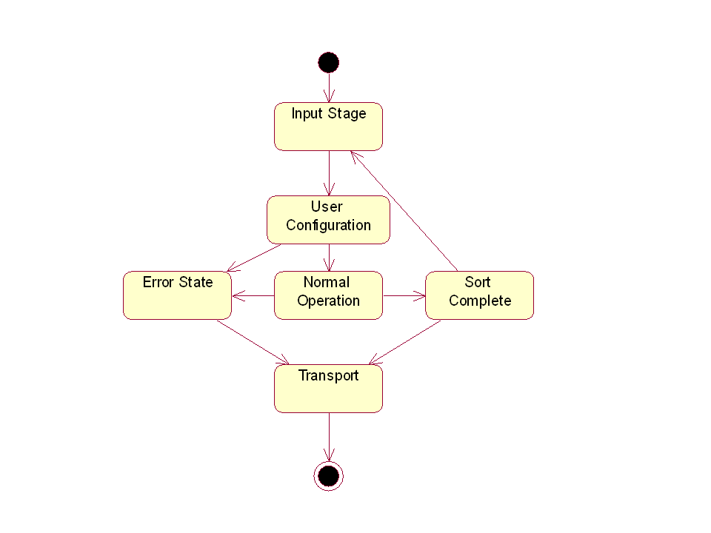

Operation in Specific States or Modes
<Describe operational aspects common to all or most of the modes or states in a generic paragraph.>
<Describe the product states and modes defined in Paragraph 4.3.1 in separate subparagraphs. Include in each subparagraph the functional and data flows associated with a particular mode or state, state and mode transitions, and user interactions with the product.>
<Typical functional flow segments include pre-mission planning, pre-mission checkout, in-transit equipment checkout, product setup, mission execution, product stand down, return to station, and post-mission analysis. Use diagrams as appropriate for clarity. Do not address timing, throughput, or other numeric measures. These belong in descriptions at lower levels of detail.>

Each of the major states is broken down into subsections which further describe the system operation.
Input Stage: TBD.
User Configuration: TBD.
Normal Operation: TBD.
Sort Complete: TBD.
Transport: TBD.
Error: TBD.

Operational Environment
<Describe the operational environment in terms of its dimensions, such as the physical environment in which the product is deployed, the signal environment in which the product operates, computer-related context, communications resources to be used, interfaces with other products, and non-technical constraints. Discuss each of these or other significant aspects of the operational environment separately.>

Support Concept
<Describe the principal maintenance concept for supporting the product during its full operational life cycle. If the main concept differs for some of the circumstances or modes defined in Paragraph, describe the corresponding concepts in separate subparagraphs.>

<Desired Goal> → Not in any way a requirement

Levels of Maintenance
<Describe maintenance levels (e.g., organizational, intermediate, depot) needed to support the product.>

Maintenance and Repair Cycles
<Describe the regularly scheduled maintenance and repair cycles, including procedures for installing software upgrades and the criteria for hardware repair and replacement.>

Personnel and Training

Operational Personnel
<Describe personnel required to operate the product in terms of duties assigned to each operational position, number of operators needed, and specialty codes or skill levels.>

Maintenance Personnel
<Describe personnel required to maintain the product in terms of levels of maintenance, number of maintainers required, and specialty codes or skill levels.>

Training Requirements
<Describe initial and periodic training to be given to product operators and maintenance personnel.>

Summary of Organizational Impacts
<Describe organizational impacts on the product user and support agencies as a result of fielding the new product. Examples of such impacts include changed operational procedures; new data sources; changes in quantity, type, and timing of data input to or from the product; changes in data retention requirements; addition, modification, or elimination of responsibilities or positions; changes in the number, specialty codes, skill levels, or location of operational and support personnel; and the need for additional personnel training.>

Product Evolution
<Broadly describe how the new product must evolve over time to incorporate new technologies, meet new operational requirements, support new missions, or meet new threats. Include features that the product must have to allow evolution.>

Disposal Concepts
<Describe the disposal concepts that meet disposal needs for the product.>

Performance Characteristics

Key Operational Requirements

Mission Critical Capabilities
<Describe product capabilities and functionalities that the user deems essential.>

Key Performance Requirements
<Describe critical product performance characteristics that the user deems essential to accomplishing the mission. Examples include product capacity, reaction time or responsiveness, and detection range. List any design restrictions (e.g., power, size, weight, or cooling) imposed on the product by the platform or facility where the product will be installed. If the product has critical set-up, transportation, and teardown requirements, describe them.>
<Note: Address only performance constraints that are fundamental to the product’s mission. Do not propose solutions to actual mission needs.>

Quality Factors
<Describe any quality factors that the user has deemed essential; e.g., product availability, reliability, maintainability, survivability, and software portability.>

- CR 2.2 On site breakdown and packing time shall be no longer than 8 minutes. [120]

Normal post operation cleaning (if any is required) shall be included when calculating breakdown and packing time. [130]
- CR 2.1 The device must be easily portable by one person. [090].
On site setup time shall be no longer than 5 minutes. [100]
- CR 1.4.2 The device shall work in a farm field environment. [060].

Measures of Effectiveness (MOEs)

Customer-Provided MOEs
<List and describe criteria the user will apply to evaluate the operational suitability and mission effectiveness of the fielded product.>

Derived MOEs
<List and describe any additional MOEs developed during the operational requirements analysis.>

Appendix A
Operational Scenarios
<Include one or more operational scenarios illustrating the role of the new product.>

A.1 Operational Scenario 1

A.2 Operational Scenario 2

A.n Operational Scenario n

THIS PAGE INTENTIONALLY LEFT BLANK
Appendix B
Support Scenarios
<Include one or more support scenarios illustrating product support.>

B.1 Support Scenario 1

B.2 Support Scenario 2

B.n Support Scenario n

THIS PAGE INTENTIONALLY LEFT BLANK
Appendix C
Other Relevant Information
<Use this appendix for information that is more detailed than is conveniently included in the main section of the document.>

THIS PAGE INTENTIONALLY LEFT BLANK
Appendix D
Acronyms and Abbreviations
<List and define all acronyms and abbreviations used in this document.>

THIS PAGE INTENTIONALLY LEFT BLANK
Appendix E
Glossary
<List key terms used in the document>

THIS PAGE INTENTIONALLY LEFT BLANK

